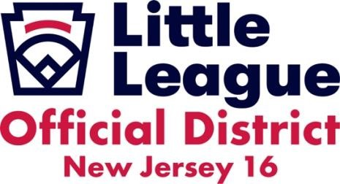
PRESIDENT’S MANDATORY MEETING
DATE: March 11, 2026
TIME: 7 PM
PLACE: Somers Point Youth Center

AGENDA:
- Roll Call
- Previous Minutes
- Reports (DA,ADA, Other)
- District Reminders and Updates
- Old Business
- New Business
- Adjourn (Next Meeting)
- Start thinking about the registration deadline
- Sports Connect update
- Hosting finals
- Interleague Agreement (roll call)
- Interleague Monitors-Atl Ct CJ, CMC Cheryl
- ACUA 2026 Umpire Association Agreement
- Interleague Stacking
- tournament blackouts
- 8-year-old tournaments
- Discontinue the Saturday tournament blackout
- Game Changer Use
- Live streaming
- Pleasantville
- Winslow boundary

